CERTIFICATE OF ATTENDANCE

This is to certify that
[Participant’s Name]
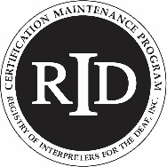
Participated in
[Activity Name]
Presented by: [Presenter Name(s)]
On [Activity Date/Beginning and End Times]
and earned [XX] [PS or GS] CEUs [XX contact hours]
Activity Code [0051 XXXX XX]

_________________________
L. Leffler, RID Sponsor Administrator

The Indiana Chapter of RID, ICRID, is an RID Approved Sponsor
02.27.2022 LL

