[activity title]  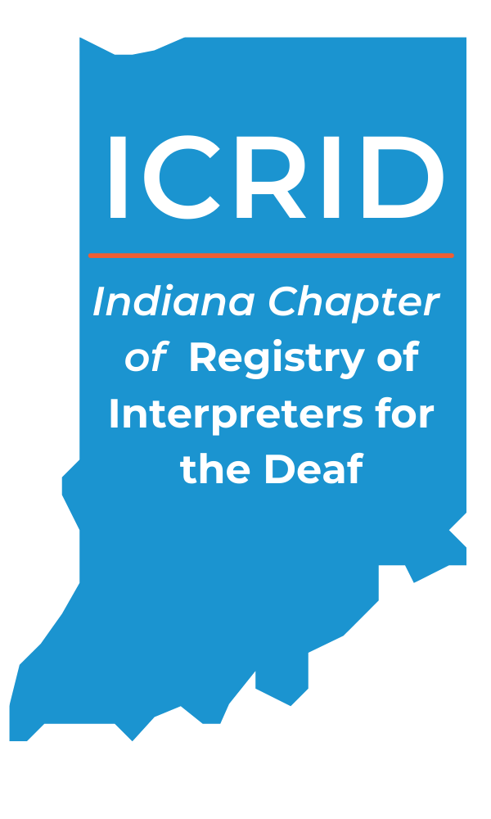  Presenter Name  *May wish to indicate if the workshop is being presented in ASL or English.  When  June 8th  8pm – 12pm  Where  [Location Name]  [Location Address]  TARGET AUDIENCE · [ Target Audience this should match what is on your Instructor Form]  EDUCATIONAL OBJECTIVES ·  [List educational objectives as described on instructor form)  Requests for accommodations made at least two weeks in advance of the activity will generally allow us to provide seamless access, but XXXX will make every effort to meet requests for reasonable accommodations made at any time.  Non-Discrimination Policy: ICRID promotes learning environments free from discrimination and bias, wherein participants demonstrate mutual respect. | Questions?  Contact:  [name  phone #  Email  Website]  registration information  [Regular Rate  Early Bird Rate  Deadline for Registration]  cancellation/refund policy  [Outline cancellation/refund policy or list web address to find them.]  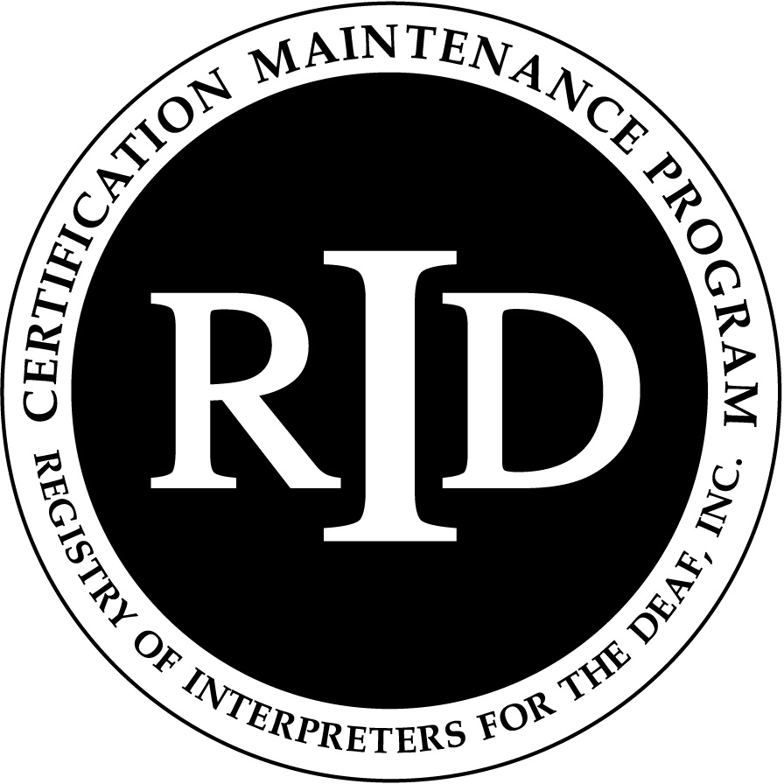  ICRID IS An Approved RID Sponsor for continuing education activities. This [PS/GS] program is offered for [XX] CEUs at the [Knowledge Level] Content Knowledge Level.

