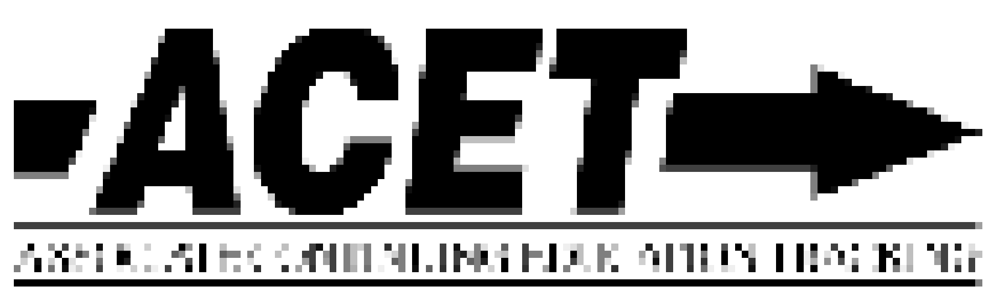
Continuing Education Activity Plan Sponsor Form

This activity must be submitted ONLINE at www.rid.org at least 30 days prior to the start of the activity. A copy of this form along with the Activity Plan Instructor’s form must be kept on file for future auditing purposes.

Name of Approved Sponsor: ICRID, Erin Kirk

Activity Number:

Activity Title:

Location of Activity :

Instructor(s) Name(s):

Contact Person/People: Contact Phone(s):

E-mail : Web site:

Who is the Target Audience:

Activity Start Date: Activity Completion Date:

Start Time for Activity: Ending Time for Activity:

Total number of CEUs to be awarded to each participant: =========================================================================== Content Area: Content Level: Participating Programs:

Professional Studies (PS) Little/none CMP only

General Studies (GS) Some ACET only

Extensive CMP & ACET Both

Teaching

As the RID Approved Sponsor for the RID activity, I certify that the above information is accurate and will be filed ONLINE with RID through www.rid.org at least 30 days prior to the start of the activity.

RID Approved Sponsor Signature Administrator: Erin Kirk 2018

