Continuing Education Activity Plan 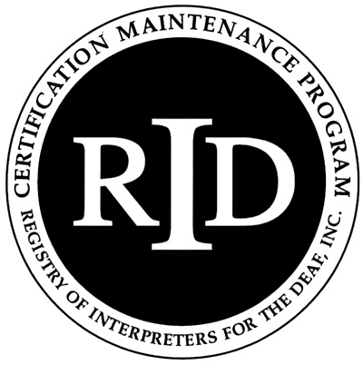
Instructor’s Form

This form is to be completed by either the instructor or RID Sponsor and kept on file with the Sponsor form.
The RID Sponsor will submit the completed Activity Plan online by logging in to their account at www.rid.org at least 30 days in advance of the activity.

RID Sponsor Name: ICRID, Erin Kirk

Presenter/Instructor Name (Please attach bio/resume):________________________________

Date(s) Time of Activity:___________ # of CEUS: ❑PS ❑GS

Title of Activity:________________________________________________________________

Level of Participant’s Prior Knowledge of Topic:
□ Little/None □ Some □ Extensive □ Teaching

Target Audience:_______________________________________________________________

Workshop/Course Description:

Educational Objectives (List specific measurable actions by participants that will demonstrate comprehension and integration of information presented):

Media/Materials (List the print, audio and visual materials you will use. Who is responsible for providing them?)

Evaluation & Assessment (Describe how you will evaluate student learning & presentation effectiveness.)

